Introduction

1.1.1 Radiochemistry
Radiochemistry is defined as “the chemical study of radioactive elements (both natural and artificial) and their use in the study of chemical processes” (The Random House College Dictionary 1984). Radiochemistry involves the application of the basic ideas of inorganic, organic, physical and analytical chemistry to the manipulation of radioactive material.

1.2. Radiation chemistry
This is a subdivision of nuclear chemistry which is the study of the chemical effects of radiation on matter. Radiation chemistry is then different from radiochemistry as no radioactivity needs to be present in the material which is being treated the radiation.
An example of such is in the conversion of water into hydrogen gas and hydrogen peroxide. Thus when water is exposed to radiation, the water absorbs energy, and as a result forms chemically reactive species that can interact with dissolved substances (solutes). In that process, water is ionized to form a solvated protons and electron (OH⁻and H₂O⁺). The formed H₂O⁺ cation can react with water to form a hydrated proton (H₃O⁺) and hydroxyl radicals (HO.). Furthermore, the solvated electron can recombine with the H₂O⁺ cation to form an excited state of the water, this excited state then decomposes to species such as (HO.), hydrogen atoms (H.) and oxygen atoms (O.).

1. 2.1 Radiation
Radiation is the transfer of energy in the form of waves or moving particles emitted by an atom or other body i.e. radiation is here referred to as the emission or transmission of energy in the form of waves or particles through space or through a material medium.

Radiation can be classified depending on its effect on atomic matter as;
- Ionizing- charged particles are directly ionizing due to coulombic interactions and scattering of the valence shell electrons of atoms
- non-ionizing radiation, The non-charged particles are indirectly ionizing as a result of transfer of energy via momentum (energy acting as a particle versus a wave).

The charge on the radiation is given by the emitted particles which may be charged or not.

1.3 Relationship between the structure of the atomic nucleus and stability
According to Niels Bohr (Bohr, 1913), an atom is regarded as a sphere consisting of extremely small central nucleus surrounded by shells containing negatively charged electrons. The electrons are rotating the central nucleus which contains positive charge carriers called protons (Z) and neutrons (N). The sum of protons and neutrons is call nucleons (A).
A (nucleons) =Z(protons, atomic number)+N(neutrons)
Z is also referred to as the atomic number
For stable atoms (nuclides), the number of protons (Z) and neutrons (N) should be “approximately” equal. This implies that if a plot of the positive charge carriers (Z) is plotted as a function of the number of neutrons (N), a straight line of unit gradient and a zero intercept is expected for most stable nuclides. The obtained straight line is called a definite belt of stability.
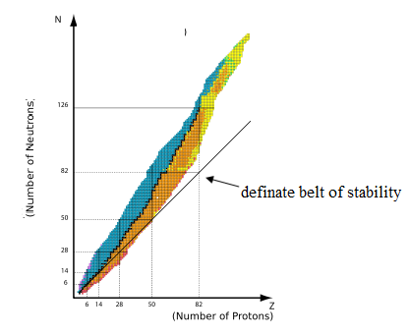
Figure 1 A plot of protons (Z) against neutrons (N)
Deviations of the N/Z ratio from unity lead to instability as the forces within the nucleus are unbalanced and thus have an excess of internal energy. Atoms whose N/Z ratio has deviated from unity are thus unstable and are called radionuclides. Atoms found in nature are either stable or unstable. The departure of N/Z ratio from unity makes the nucleus imbalanced. This implies that an atom is unstable (radioactive) as the forces within the nucleus are unbalanced since it has an excess of internal energy. Unstable atoms are called radionuclides. The instability of a radionuclide's nucleus may result from an excess of either neutrons or protons. An unstable nucleus will continually vibrate and contort in an attempt to attain stability. As a result, it may:-
- Eject neutrons, and protons
- Convert one to the other with the ejection of a beta particle or positron
- The release of additional energy by photon (i.e., gamma ray) emission.
1. However, as the nuclear charge increases beyond 20, the N/Z ratio deviates from unity as N > Z making N/Z >1. Therefore all atoms with Z > 20 irrespective they are stable or not lie above the N-Z line. This behaviour is contributed by the increase in the number of protons causing repulsion between them resulting to a lower stability of the nucleus.
N/Z=1 stable low atomic number
N/Z>1 unstable high atomic number

1.3.1 BALANCING FORCES IN ONE PLANE
Consider a thin disc or wheel (Figure 2) on which the centre of gravity is not the same as the centre of rotation. When put in motion, the centre of gravity will always come to rest below the centre of rotation like a pendulum. However, if it is balanced it will come stationary at any point no matter which position it is turned to.

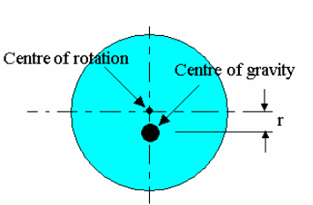
Figure 2 Disc with the centre of gravity is not the same as the centre of rotation

If the centre of gravity is distance r from the centre of rotation then when it spins at
ω rad/s, centrifugal force is produced. This has a formula
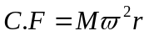
where M is the mass of the disc
When an unbalanced system is rotating, periodic linear and/or torsional forces are generated which are perpendicular to the axis of rotation. The periodic nature of these forces is commonly experienced as vibration. These off-axis vibration forces subjected centre of rotational to perpendicular torsion forces due to the instantaneous linear forces. Such a system is the out of balance force. In order to cancel it out an equal and opposite force is needed. This is simply done by adding a mass M₂at a radius r₂ as shown.

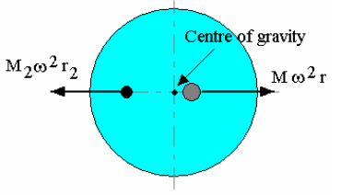
Figure 3 Balance done by adding a mass M₂ at a radius r₂

The two forces must have the same magnitudes. Thus
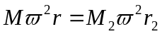 r₂
Placing a suitable mass at a suitable radius moves the centre of gravity to the centre of rotation. This balance holds true at all speeds down to zero hence it is balanced so long as the products of M and r are equal and opposite. This can also be achieved not by addition of mass, but also by removal of mass equal and opposite to the force is needed. This is the situation that takes place when the N-P ratio has deviated from 1

Other factors affecting nuclear stability
Studies have established that nuclei with number of protons and neutrons are equal to 2, 8, 20, 28, 50, 82 and 126 are more stable and abundant in nature. These numbers are called 2. magic numbers.

It has been also observed that nuclei with 3. even number of protons and neutrons (gerade symbolised “g”) are more stable than those containing an odd number of protons and neutrons (ungerade symbolised “u”). There are several types of nuclides. These include isobaric, isotopic, isodiapheric, and isomeric nuclides.
- even number of protons and neutrons (“g, g”)
- even number of protons and odd neutrons (“g, u”)
But the neutron to proton (n/z) ratio is the dominant factor in nuclear stability. This ratio is close to 1 for atoms of elements with low atomic number and increases as the atomic number increases. Then, how do we predict the nuclear stability? One of the simplest ways of predicting the nuclear stability is based on whether nucleus contains odd/even number of protons and neutrons.

Figure 4 Table showing trend of stability in gerade and ungerade nuclides
Protons | Neutrons | Number of Stable Nuclides | Stability
Odd | Odd | 4 | least stable
Odd | Even | 50
Even | Odd | 57
Even | Even | 168 | most stable

- Nuclides containing odd numbers of both protons and neutrons are the least stable means more radioactive.
- Nuclides containing even numbers of both protons and neutrons are most stable means less radioactive.
- Nuclides contain odd numbers of protons and even numbers of neutrons are less stable than nuclides containing even numbers of protons and odd numbers of neutrons
In general, nuclear stability is greater for nuclides containing even numbers of protons and neutrons or both.

Example question
Based on the even-odd rule presented above, predict which one would you expect to be radioactive in each pair?
(a) ¹⁶₈O and ¹⁷₈O
(b) ³⁶₁₇Cl and ³⁵₁₇Cl
(c) ²⁰₁₀Ne and ¹⁷₁₀Ne
(d) ⁴⁰₂₀Ca and ⁴⁵₂₀Ca
(e) ¹⁹⁶₈₀ Hg and ¹⁹⁵₈₀Hg
Answer
  - The ¹⁶₈O contains 8 protons and 8 neutrons (even-even) and the ¹⁷₈O contains 8 protons and 9 neutrons (even-odd). Therefore, ¹⁷₈O is radioactive.
  - The ³⁵₁₇Cl has 17 protons and 18 neutrons (odd-even) and the ³⁶₁₇Cl has 17 protons and 19 neutrons (odd-odd). Hence, ³⁶₁₇Cl is radioactive.
  - The ²⁰₁₀Ne contains 10 protons and 10 neutrons (even-even) and the ¹⁷₁₀Ne contains 10 protons and 7 neutrons (even-odd). Therefore, ¹⁷₁₀Ne is radioactive.
  - The ⁴⁰₂₀Ca has even-even situation and ⁴⁵₂₀Ca has even-odd situation. Thus, is ⁴⁵₂₀Ca radioactive.
  - The ¹⁹⁵₈₀Hg has even number of protons and odd number of neutrons and the ¹⁹⁶₈₀ Hg has even number of protons and even number of neutrons. Therefore, ¹⁹⁵₈₀Hg is radioactive.

1.4 Isobaric nuclides
These are nuclides with the same number of nucleons A= (N+Z). Examples ⁹⁶₃₈Sr, ⁹⁶₃₉Y, and ⁹⁶₄₀Sr. Bar mean high. They have the same bar value.
1.5 Isotopic nuclides
These are nuclides with the same number of protons (Z) but have different number of neutrons. Examples are ²³⁴₉₂U, ²³⁵₉₂U, and ²³⁶₉₂U. In this case, Z=92.
What are radioisotopes?
Isotopes are element have the same number of protons in their atoms (atomic number) but different masses due to different numbers of neutrons. In an atom in the neutral state, the number of external electrons also equals the atomic number. These electrons determine the chemistry of the atom. The atomic mass is the sum of the protons and neutrons. There are 82 stable elements and about 275 stable isotopes of these elements.

1.5 Isodiapheric nuclides
These are nuclides with the same excess number of neutrons over protons (A-2Z=N-Z=constant). Examples are ³⁰₁₄Si, ³²₁₅P, ³⁴₁₆S and ³⁶₁₇CI In this case the constant is 2.
Example From the equation (A-2Z=N-Z=constant)
Then, For Si-[30-(2x14)=(16-14)=2]; For P- [32-(2x15)=(17-15)=2]

1.6 Isomeric nuclides
These are nuclides that differ neither in the number of protons nor neutrons but only in the nuclear binding energies.
Examples are ³⁰₁₄Si, ³²₁₅P, ³⁴₁₆S and ³⁶₁₇CI.

1.6.2 Nuclear isomerism

1.6.2.1 Mattauch isobar rule

The Mattauch isobar rule, formulated by Joseph Mattauch in 1934, states that if two adjacent elements on the periodic table have isotopes of the same mass number, one of these isotopes must be radioactive. Two nuclides that have the same mass number (isobar) can both be stable only if their atomic numbers differ by more than one. However, this rule cannot make predictions on the half lives of these radiisotopes.
A consequence of this rule is that technetium and promethium both have no stable isotopes as each of the elements just before and just after these two unstable elements on the periodic table (molybdenum- ruthenium and neodymium-samarium respectively) have a stable isotope for each mass number for the range in which the isotopes of the unstable elements usually would be stable to beta decay. These ranges can be calculated using the liquid drop model (for example the stability of technetium isotopes).
The only known exceptions to the Mattauch isobar rule are the cases of antimony-123, tellurium-123, hafnium-180 and tantalum-180m, where both nuclei are observationally stable. It is predicted that ¹²³Te would undergo electron capture to form ¹²³Sb, but this decay has not yet been observed; ^{180m}Ta should be able to undergo isomeric transition to ¹⁸⁰Ta, beta decay to ¹⁸⁰W, electron capture to ¹⁸⁰Hf, or alpha decay to ¹⁷⁶Lu, but none of these decay modes

1.7 What is radioactivity?
This is a series of transformations by unstable nuclei of atoms resulting to spontaneous disintegrations due to imbalance of energy within the nucleus. When the nucleus loses a neutron, it gives off energy and is said to be radioactive. It can also be referred to as a spontaneous loss of matter in terms of particles or radiation by a nucleus trying to attain stability. Thus Radioactivity is the release of energy and matter that results from changes in the nucleus of an atom. The radioactive process is a sub atomic change within an atom. This results in new elements or a lower energy state of the atoms. In nuclear decay, particles or electromagnetic radiation are emitted or the nucleus undergoes spontaneous fission or electron capture.

In the process, the unstable nucleus disintegrates as it emits radiation and particles and the radionuclide transforms to different nuclide. The process is called radioactive decay. The process continues until the forces in the nucleus are balanced. Finally, as a radionuclide decays, it becomes a different isotopes of the same element if the number of neutrons changes and a different element altogether if the number of protons changes.
The nucleus of a radioisotope attains stability by emitting an alpha and/or beta particle (or positron). These particles may be accompanied by the emission of energy in the form of electromagnetic radiation known as gamma rays. This process is known as radioactive decay.
Example a beta particle is not an electron outside a nucleus, but one formed when a neutron changes to a proton with release of an electron within a nucleus. This results into an increase of the positive charge
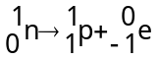

1.7.1 The Discovery of Radioactivity
Radioactivity was discovered by Henri Becquerel (1896) when he developed photographic plates and found out that the photographic material (AgX) has been reduced, proving that the uranium emitted radiation without an external source of energy such as the sun. He attributed the energy on the observed phenomenon to radioactivity.
Becquerel used an apparatus similar to that displayed below to show that the radiation he discovered could not be x-rays as they were affected by magnetic and electric fields unlike X-rays. Due to the deflection of the radiation by magnetic field, it must be charged and thus different than x-rays. He further discovered that the radiations were deflected in different directions or not at all, showing that there were three classes of radiations or particles. Thus negative, positive, and electrically neutral.
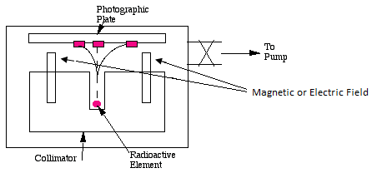
Figure 5 Becquerel apparatus showing three classes of radioactivity
The term radioactivity was actually coined by Marie Curie, who together with her husband Pierre, as they were investigating the phenomenon that was discovered by Becquerel. The Curies extracted uranium from ore and to their surprise, found that the leftover ore showed more activity than the pure uranium. They concluded that the ore contained other radioactive elements.
This led to the discoveries of the elements polonium and radium. Ernest Rutherford, who did many experiments studying the properties of radioactive decay, named these alpha, beta, and gamma particles, and classified them by their ability to penetrate matter. Rutherford used an apparatus similar to that depicted in Fig. 1. When the air from the chamber was evacuated (removed), the alpha source made a spot on the photographic plate. When air was pumped into the chamber, the spot disappeared. Thus, this revealed that, only a few centimetres of air were enough to stop the alpha radiation.
Because alpha particles carry more electric charge, are more massive, and move slowly compared to beta and gamma particles, they interact much more easily with matter. Beta particles are much less massive and move faster, but are still electrically charged. A sheet of aluminium one millimetre thick or several meters of air will stop these electrons and positrons. Because gamma rays carry no electric charge, they can penetrate large distances through materials before interacting–several centimetres of lead or a meter of concrete is needed to stop most gamma rays.
Two basic units used to describe the amount of activity in a sample are the Curie and Becquerel.

1.7.2 The decay process
All unstable nuclei decompose spontaneously with emission of particles (α and β) and energy in the form of radiation (Ɣ). If the decay product is unstable, the process will continue till a stable non-radioactive nuclear is formed. When β-particle (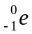) is emitted the atomic number increase by 1 and mass number remain constant. This is because a neutron is changed to a proton and hence releases an electron which results in the increase of the positive charge. But the mass of the nuclide does not change even after the nuclide transforms to a different atom.

1.8 Nuclear masses and binding energies
Binding energy is the amount of energy required to split an atom into individual particles. This means that stable atoms have a binding energy that is strong enough to hold the protons and neutrons together.
The nucleon number (A=Z+N) and is a whole number. The mass of the nucleon is also called the atomic mass and is given in relation with a fraction of carbon 12 isotope. From Einstein’s relationship equation 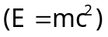 between mass and energy, the binding energy of a nucleon can therefore be evaluated when it disintegrates. This is done by considering the change in energy 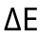in relation with change in mass.

1.8.1 Mass change
Mass change in bound systems, particularly atomic nuclei, has also been termed mass defect, mass deficit, or mass packing fraction.
The difference between the unbound system calculated mass and experimentally measured mass of nucleus (mass change) is denoted by Δm. It can be calculated as follows:
Mass change = (unbound system calculated mass) - (measured mass of system)
i.e., (sum of masses of protons and neutrons) - (measured mass of nucleus)
After nuclear reactions that result in an excited nucleus, the energy that must be radiated or otherwise removed as binding energy for a single nucleus may be in the form of electromagnetic waves, such as gamma radiation, or it may appear in the kinetic energy of an ejected particle, such as an electron, in internal conversion decay. Also, energy of excitation of nucleus can be partly emitted as the rest mass of one or more a particle, such as the emitted particles of beta decay. Again, however, no mass deficit can in theory appear until this radiation or this energy has been emitted, and is no longer part of the system.
When nucleons bind together to form a nucleus, they must lose a small amount of mass, i.e., there is mass change, in order to stay bound. This mass change must be released as various types of photon or other particle energy as above, according to the relation E = mc². Thus, after binding energy has been removed, binding energy = mass change × c². This energy is a measure of the forces that hold the nucleons together, and it represents energy which must be supplied again from the environment, if the nucleus were to be broken up into individual nucleons.
The change in mass (mass defect) is given by
(eq 3)
Where m_{p}, m_{n}, m_{e} and m_{H} are the masses of protons, neutrons electrons and hydrogen atom respectively and m is the mass atom in question.
Applying the Einstein’s relativity, the energy that used to bind or split an atom of 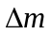can be evaluated using the provided equation (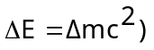. The 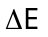is called the binding energy (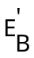). When the binding energy () is divided by the number of nucleons (A), the average binding energy per nucleon (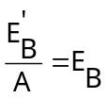) is obtained
Equation 3 was applied to determine the binding energy of a helium atom as shown below. If the mass of Helium is 4.00204, mass of hydrogen atom is 1.007825 and mass of neutron 1.008665,
Then the change in mass will be:-
To convert mass difference into electron volts, it is done by multiplying with 931.4 MeV which gives the binding energy to be 28.30 MeV. The binding energy per nucleon for helium was obtained by dividing the later with the nucleon number 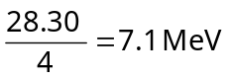
From such calculations, it has been established that nuclides with A greater than 11 (Z>5) have their binding energies per nucleon between 7.4 - 8.8 MeV. The same calculations have confirmed that the energies per nucleon reaches maximum for nucleons around 60- for cobalt, iron and nickel implying that these elements are most stable. Figures 6 A and B show the relationship between binding energies per nucleon and the number of nucleon.
Table 1 Calculations of binding energy of some selected nuclides.
M_{P} | M_{N} | AMU
1.007825 | 1.008665 | 931.502
 | Z | N | Mass | T_{Z} | T_{N} | C_{Mass} | Defect | E'_{B} | A | REAL E_{B}
⁵⁶Fe | 26 | 30 | 55.934939 | 26.20345 | 30.25995 | 56.4634 | 0.528461 | 492.2583 | 56 | 8.7906
⁵⁸Fe | 26 | 32 | 57.932276 | 26.20345 | 32.27728 | 58.48073 | 0.548454 | 510.8816 | 58 | 8.7925
⁶⁰Ni | 28 | 32 | 59.93079 | 28.2191 | 32.27728 | 60.49638 | 0.56559 | 526.8437 | 60 | 8.7925
⁶²Ni | 28 | 34 | 61.928345 | 28.2191 | 34.29461 | 62.51371 | 0.585365 | 545.264 | 62 | 8.7948
n | 0 | 1 | 1.008665 | 0 |  |  |  |  | 1
¹H | 1 | 0 | 1.007825 | 1.007825 |  |  |  |  | 1
²H | 1 | 1 | 1.007051
³H | 1 | 2 | 1.00535
³He | 2 | 1 | 1.005343
⁴He | 2 | 2 | 4.00204

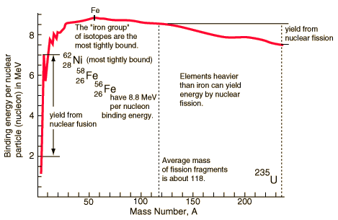
Figure 6 Binding energies of some nuclides

1.9 Radioactive decay
An unstable nucleus will continually vibrate and contort, then disintegrates in attempt to attain stability. In the process, it ejects neutrons and protons converting a nuclide from one to the other releasing energy in form of alpha, beta particle or positron and energy by photon (i.e., gamma ray) emission.
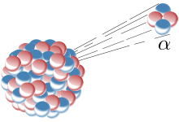
Figure 7 An example of an unstable nucleus disintegrates release alpha particle
Summary
- As an unstable atom tries to reach a stable form, energy and matter are released from the nucleus. This spontaneous change in the nucleus is called radioactive decay.
- When there is a change in the nucleus a nuclide (atom) changes into another. This process is called transmutation
Alpha decay is one example type of radioactive decay, in which an atomic nucleus emits an alpha particle, and thereby transforms (or 'decays') into an atom with a mass number decreased by 4 and atomic number decreased by 2. Many other types of decays are possible.

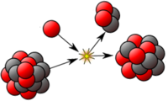
Figure 8 Transmutation of an unstable nucleus
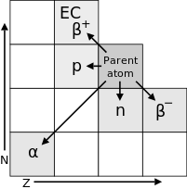
Figure 9 radioactive decay

1.9.1 Radioactive materials
Based on the n/p ratio, practically all materials contain radionuclides, but at very low activities. This is because they are atomically unstable. 4. However, all elements with atomic numbers greater than 83 are radioisotopes meaning that these elements have highly unstable nuclei and are radioactive. Elements with atomic numbers of 83 and less have isotopes (stable nucleus) and most have at least one radioisotope (unstable nucleus).
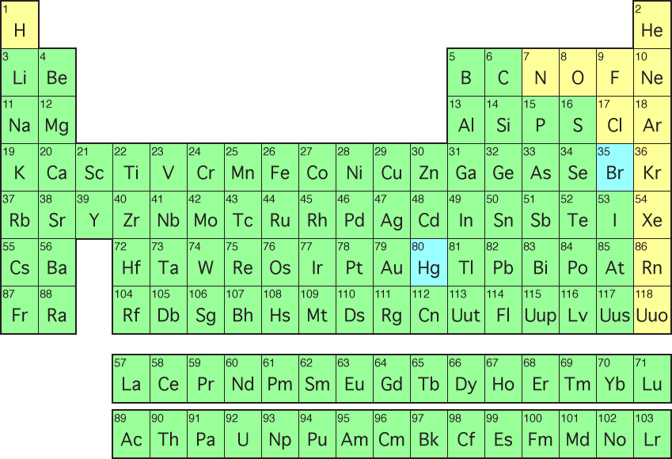
Figure 10 Elements of the periodic table
There are both natural and synthetic (artificially produced radioisotopes) radioactive materials. Radionuclides, like x-ray, and particle accelerators generate radiation. Some of the generated particles have a high penetrating and ionizing ability that cannot be detected by the human senses. This means that an exposure to radionuclides is unsafe. The dangers of radioactivity and radiation were first observed by and electrical engineer and physicist Nikola Tesla while using X-rays. He intentionally subjected his fingers to X-rays in 1896 and observed that burns developed on the exposed parts. He published his observations concerning the burns and attributed them to ozone rather than to X-rays. His injuries later healed.
The genetic effects of radiation, including the effect of cancer risk, were recognized much later. In 1927, Hermann Joseph Muller published research showing genetic effects, and in 1946 was awarded the Nobel prize for his findings.
Before the biological effects of radiation were known, many physicians and corporations began marketing radioactive substances as patent medicine in the form of glow-in-the-dark pigments. Radioisotopes are known to cause anemia, upon exposure to ionizing radiation.
This calls for safety precautions during handling and storage of radionuclide materials. The methods used to guard against exposure to radiation include:
- short exposure time,
- distance, and
- Shielding.
The penetration power depends on the type of particle. Alpha particles may be completely stopped by a sheet of paper, beta particles by aluminum shielding. Gamma rays can only be reduced by much more substantial mass, such as a very thick layer of lead.

Summary

What's the difference between radiation and radioactivity?
Radiation is the mode of transfer of energy released from a source and travels through some material or space. Such energy is in form of particles or rays.
Radioactivity is the property of an atom that describes spontaneous changes within its nucleus to create a different nuclide. These changes usually happen as emissions of alpha or beta particles and often gamma rays. The rate of emission is referred to as a material's activity.
Each occurrence of a nucleus emitting particles or energy is referred to as disintegration. The number of disintegrations per unit time is called the activity of a sample.(Since each disintegration transforms the atom to a new nuclide, transformation is often substituted for disintegration in talking about radioactive decay and activity.)

